Michael Fang
Laboratory 5

Report:
DL’d Iris.xlxs, IBM Watson machine learning, Apache Spark, all lite versions.

Redid order of implementation since lite services only allow one instance at a time; Cloud storage to start project, then in Settings add Watson and Apache, as well as the data file.

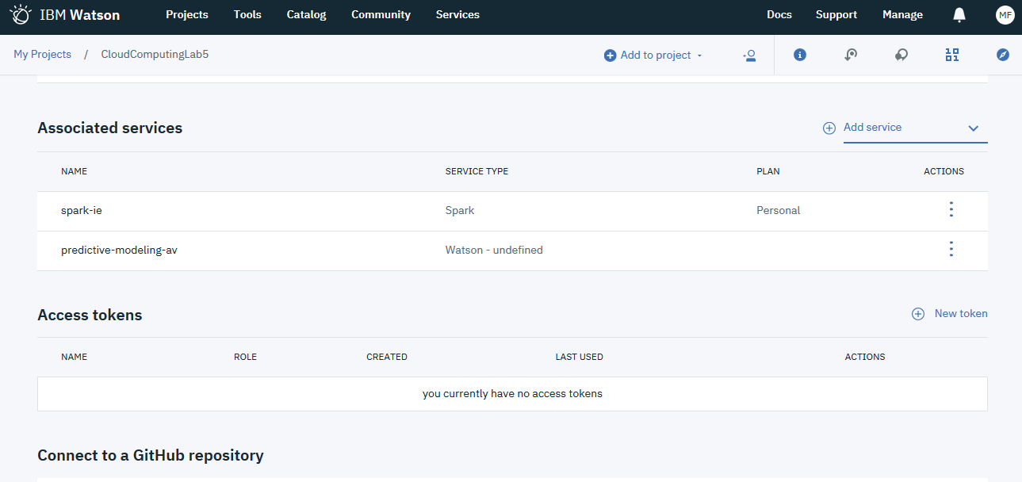

Credentials created (posting here because instance deleted after this lab anyway):
{
"apikey": "Hv3QuV9VwU0yl7yK80cEPdNEnLI2mtP_f9IRQ01HJLsj",
"cos_hmac_keys": {
"access_key_id": "0420fefeb22744a79b09a3c21a28b32a",
"secret_access_key": "3ccbc97f47c576bdaae2884c8f4df6e662a33d2c206afe96"
},
"endpoints": "https://cos-service.bluemix.net/endpoints",
"iam_apikey_description": "Auto generated apikey during resource-key operation for Instance - crn:v1:bluemix:public:cloud-object-storage:global:a/59519ad195f5532f1693540f113aec15:abceb0bc-dbbd-4354-a58c-6a2f2d973fe1::",
"iam_apikey_name": "auto-generated-apikey-0420fefe-b227-44a7-9b09-a3c21a28b32a",
"iam_role_crn": "crn:v1:bluemix:public:iam::::serviceRole:Writer",
"iam_serviceid_crn": "crn:v1:bluemix:public:iam-identity::a/59519ad195f5532f1693540f113aec15::serviceid:ServiceId-3f657c71-297e-4513-a567-4595c9a5f279",
"resource_instance_id": "crn:v1:bluemix:public:cloud-object-storage:global:a/59519ad195f5532f1693540f113aec15:abceb0bc-dbbd-4354-a58c-6a2f2d973fe1::"
}

Model Builder tool model training:

Unfortunately model builder would not load even after confirmation (I emailed IBM support but received no reply. )

However, I have read through the pages describing the model training as per:
>https://www.kaggle.com/sasiprasanth/tensorflow-neural-network-tutorial-with-iris-data
>https://www.kaggle.com/akhileshjoshi/iris-classification-using-tensorflow

By hand, we can fairly easily determine the weights for iris setosa, iris versicolor, and iris virginica to be 0.247, 0.143, and 0.105, respectively.

As someone with a background in biology (and hence why I’m so terrible at getting this computer business working), I find the results to be a bit disconcerting. Association does not imply causation, after all, and improper or misinformed presentation of the raw data may lead to wildly improper conclusions, even if the logic of the intervening steps is sound and rigorous.

